**Step wise working of Project**

**Step 1:-**

* **Splash Screen**

This will be the Splash Screen of app.

This will be appeared on screen at startup.

Background App Processes will be loaded within duration of appearance of splash screen.

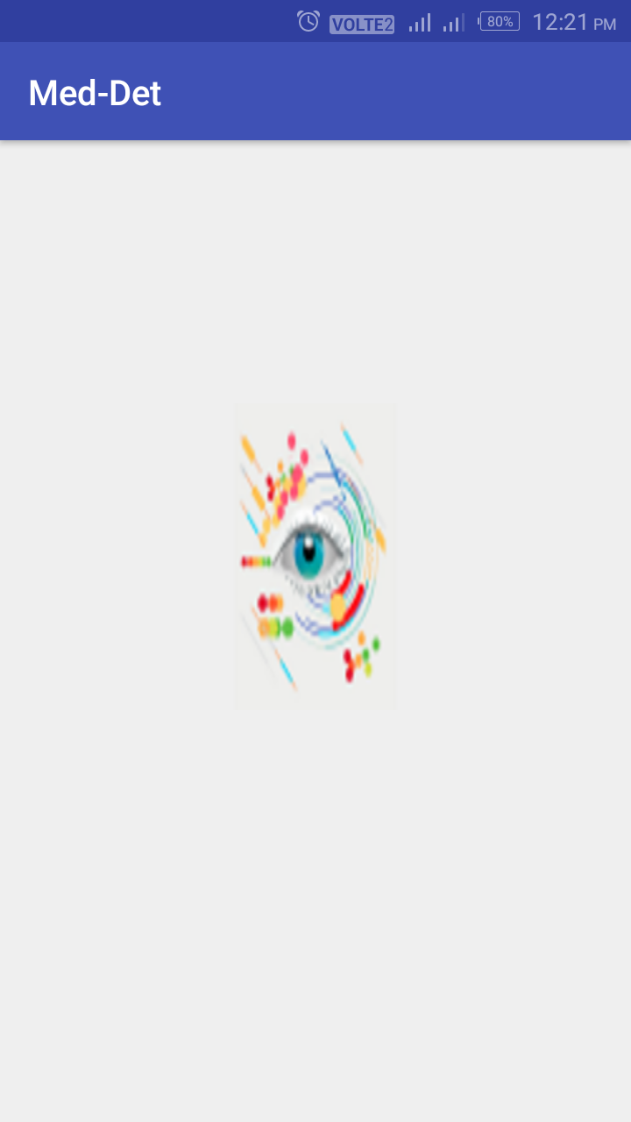

**Step 2:-**

* **Home Screen**

This will be the Home Screen of app.

It consist of 2 buttons and Name of App. To inform the location of button on screen, touch and slide option will speak the Name of Button.

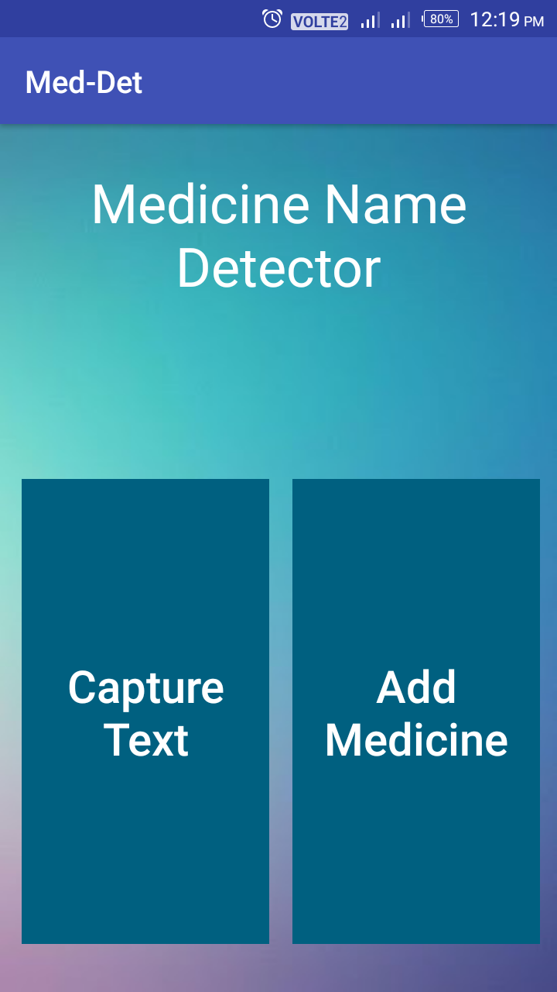

**Step 3:-**

* **Scanning Screen**

This will be the Scanning Screen of app.

This screen will appear when user clicks capture text button. This screen scans the image of medicine wrapper and detects text from that image using OCR.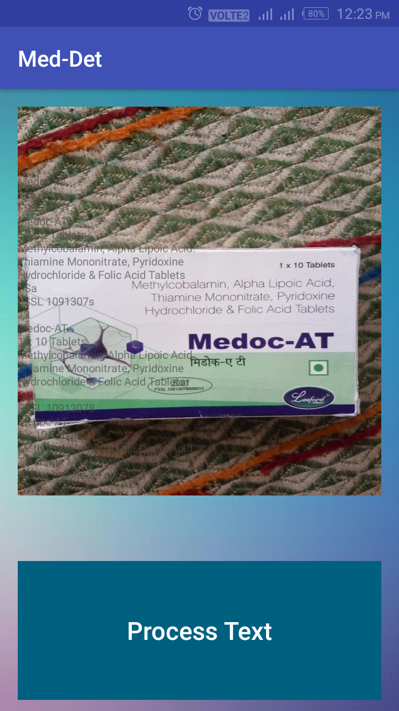

**Step 4:-**

* **Final Screen**

This will be the Final Screen of app.

This screen will speak the name and use of medicine after correct detection.

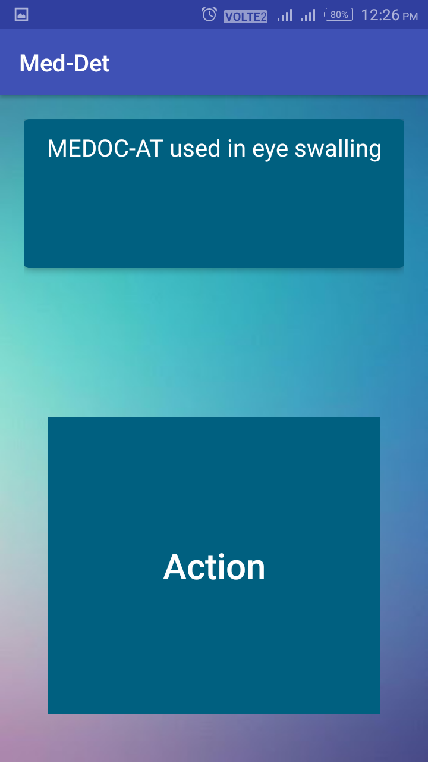

**Step 5:-**

* **Final Screen**

This screen will appear when medicine name is not detected properly.

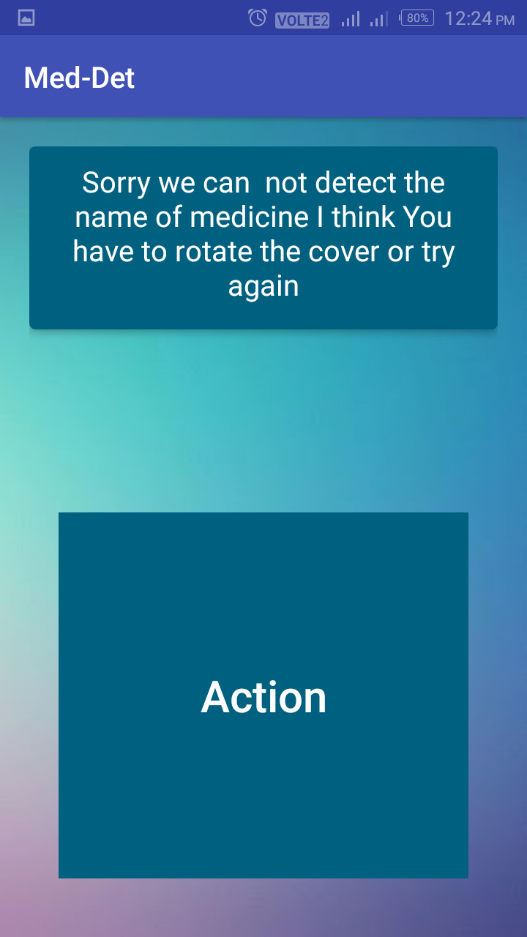

**Step 6:-**

* **Add-up Screen**

This will be the Add-up Screen of app.

This will appear when user clicks add medicine button of home screen. In this Screen Customized name of medicine and its use is added.

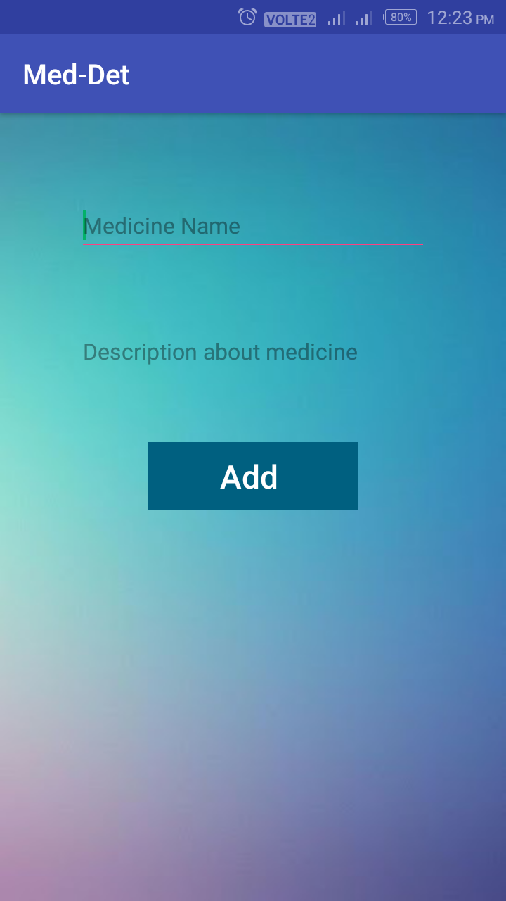

**Step 7:-**

* **Add-up Screen**

This will be the Add-up Screen of app with an error on toast.

This will appear when user proceeds without entering any text in either fields.

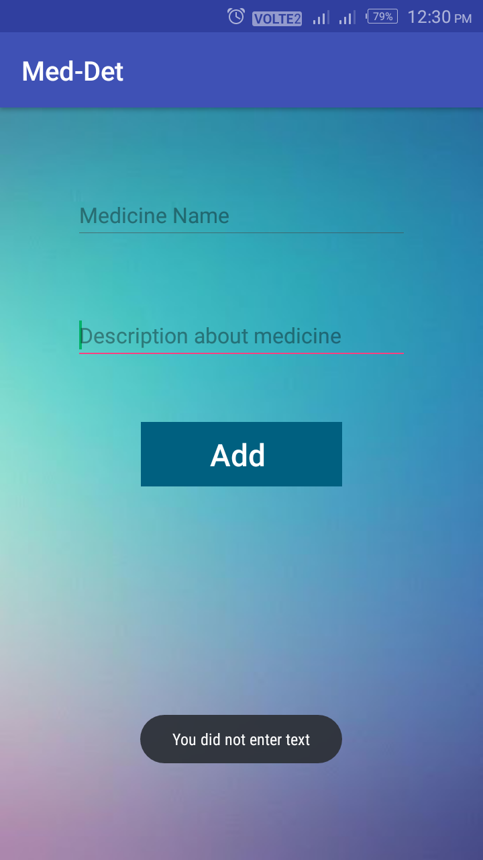

**Step 8:-**

* **Add-up Screen**

This will be the Add-up Screen of app.

This will be the final screen when new medicine is added to the sharedpreferences of app.

